User Manual

1. **Task 1**
   1. **How to launch it?**

Change directory to Task1 and execute command “java NetAnalyser”.

* 1. **The UI**

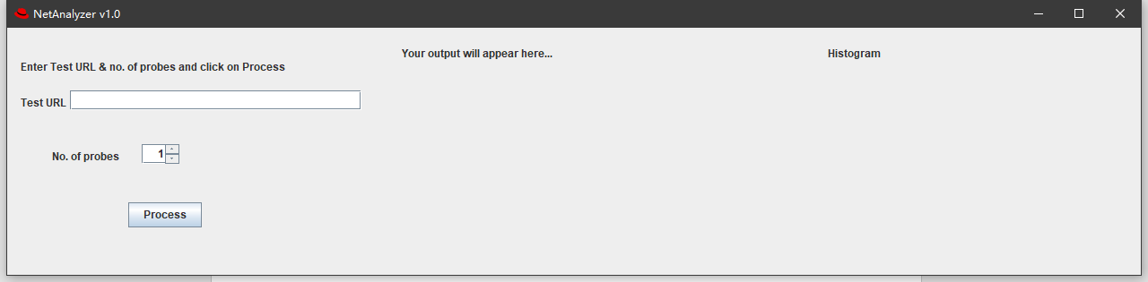

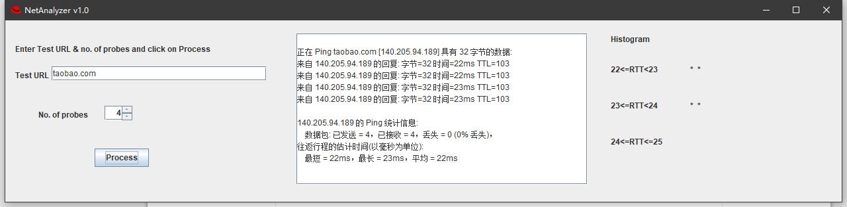

* 1. **Operating Instructions**

1. enter the Test URL
2. select the number of probes
3. click “Process” button
4. If no exceptions, there will be a textarea and a histogram
5. **Task 2**
   1. **How to launch it?**

Change directory to Task2 and execute command “java NetAnalyser”.

* 1. **The UI**





* 1. **Operating Instructions**

1. enter the Test URL
2. select the number of probes
3. click “Process” button
4. If no exceptions, there will be a textarea and a histogram
5. There will be a text file in Task2.

